DATA SCIENCE

UNSTRUCTURED TO STRUCTED USING WEB SCRAP

2019272037 - SRILAKSHMI P

2019272027 - NOORUL AMEEN

2019272020 - MADHUMITHA S

INSTALLING VPN :

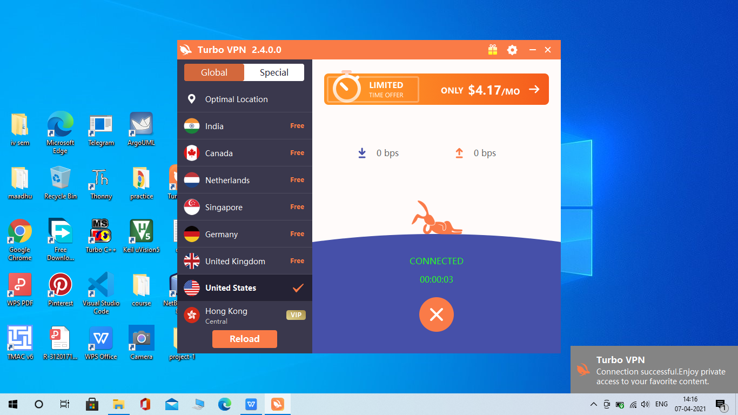

INSTALLING SCRAPY :

Pip install scrapy

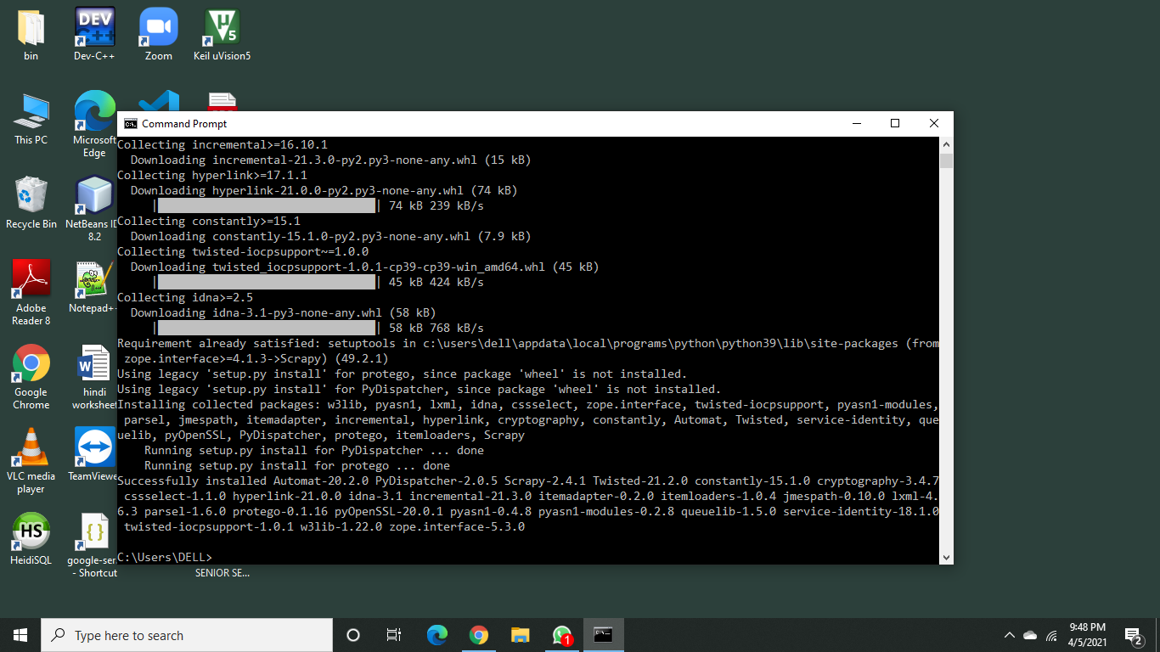

INSTALLING SCRAPY USER AGENT :

Pip install scrapy_user_agents

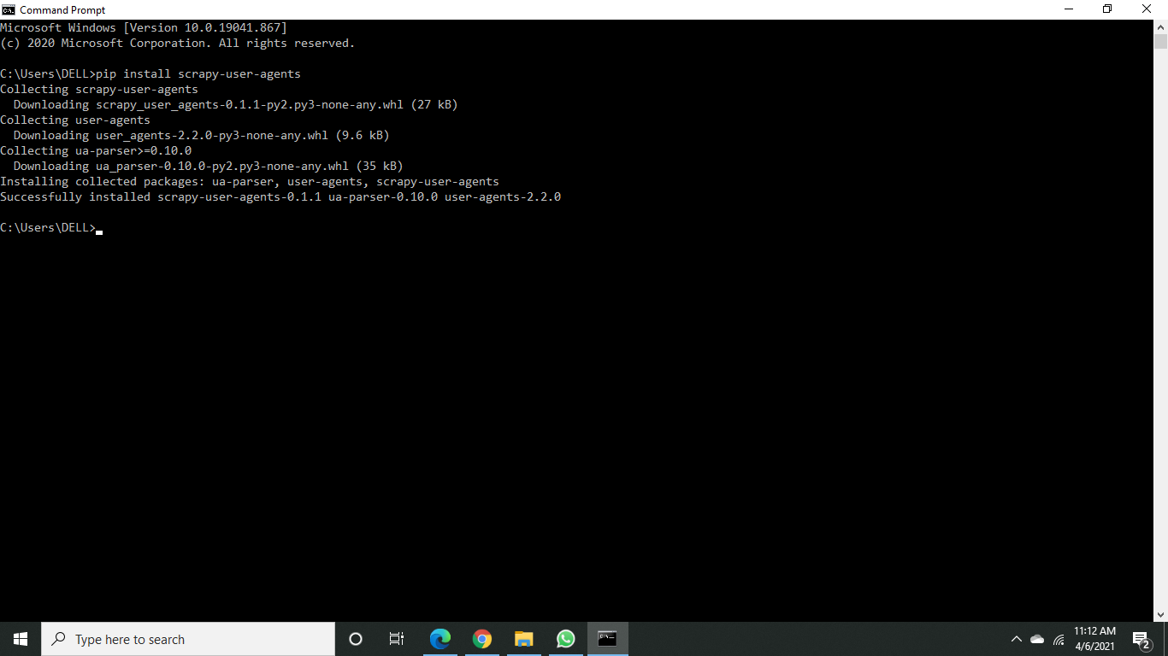

CREATING PROJECT IN SCRAPY :

Scrapy startproject project_name

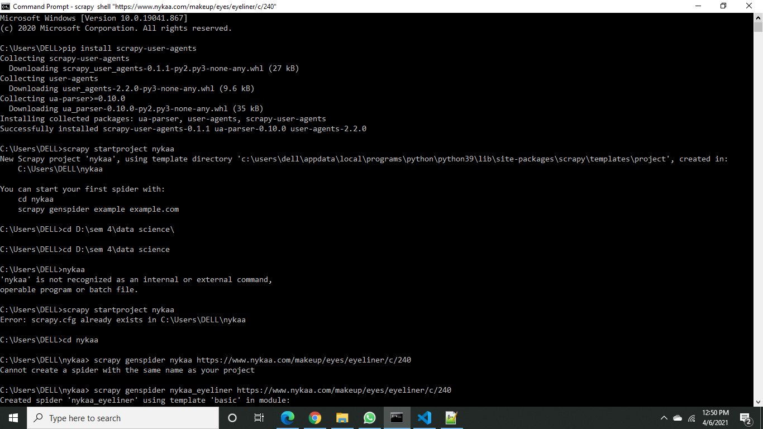

EDIT SETTINGS.PY IN PROJECT:

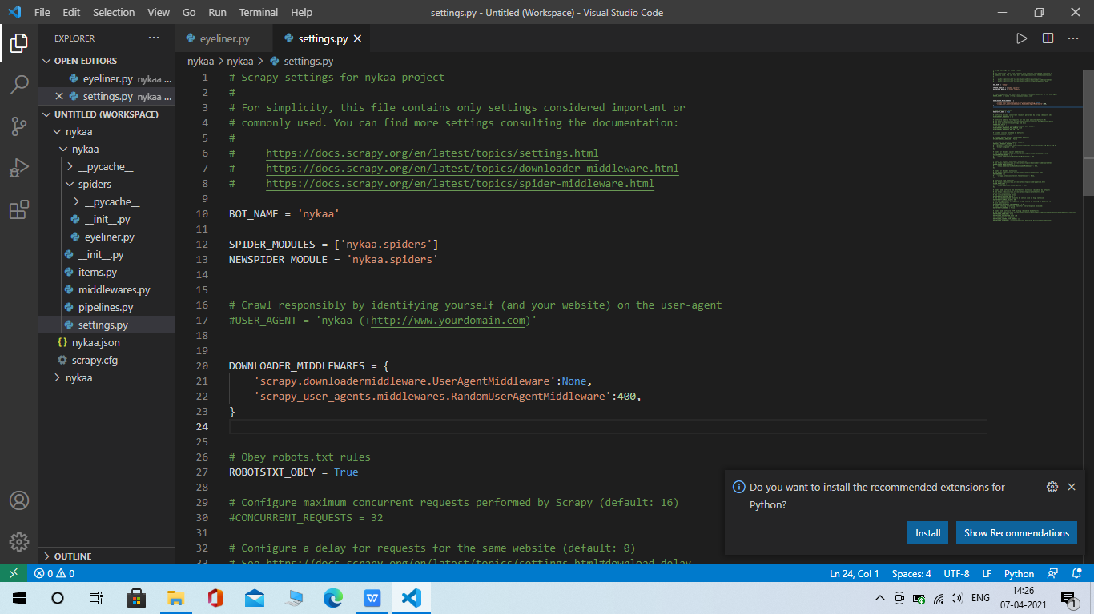

CREATE SCRAPY CRAWL GENSPIDER APP:

Scrapy genspider spider_name “link of website”

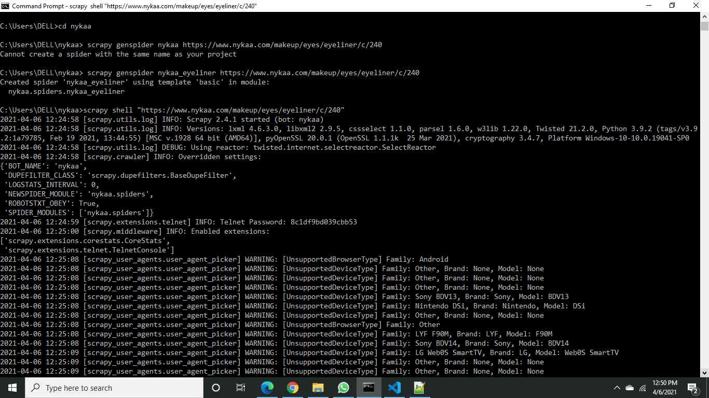

CODE FOR SCRAP DATA FROM WEBSITE:

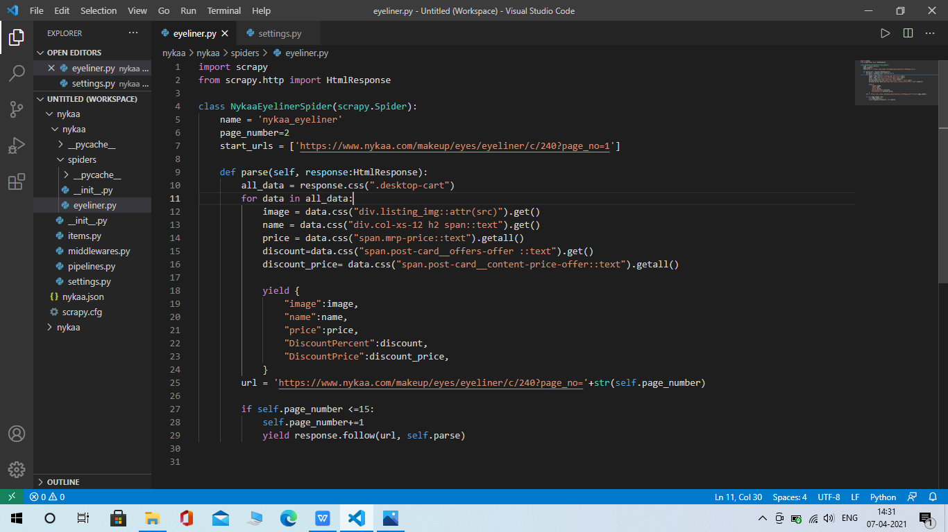

START SCRAPY SHELL :

Scrapy shell “link of website”

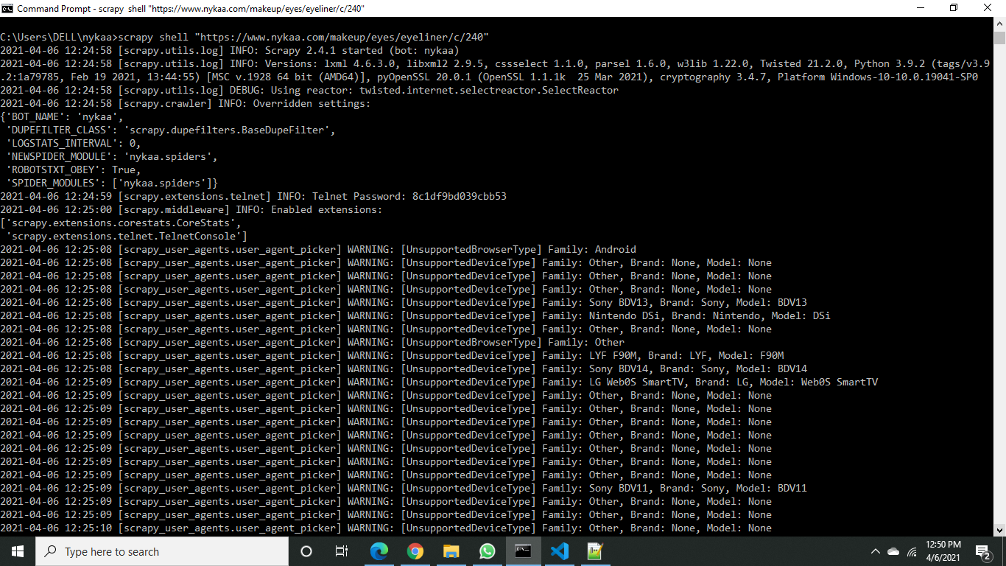

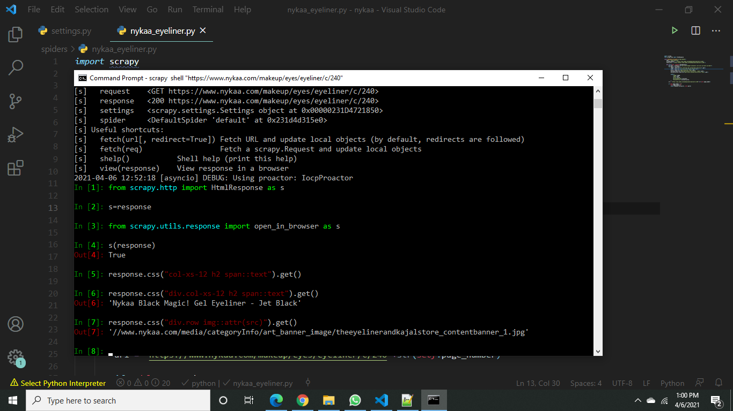

SCRAPY CRAWL AND GET DATA AS JSON :

Scrapy crawl spider_name -o file_name.json

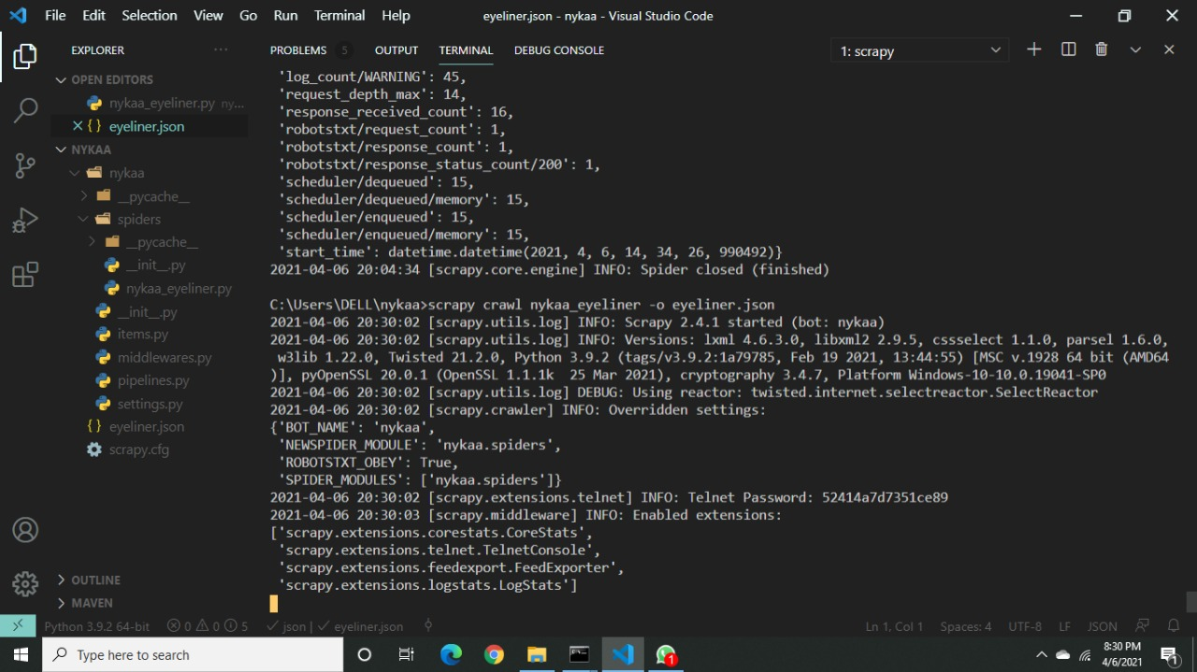

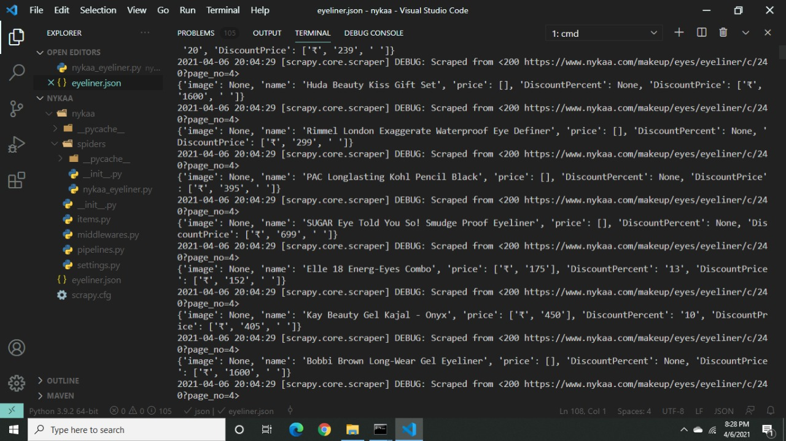

JSON FILE :

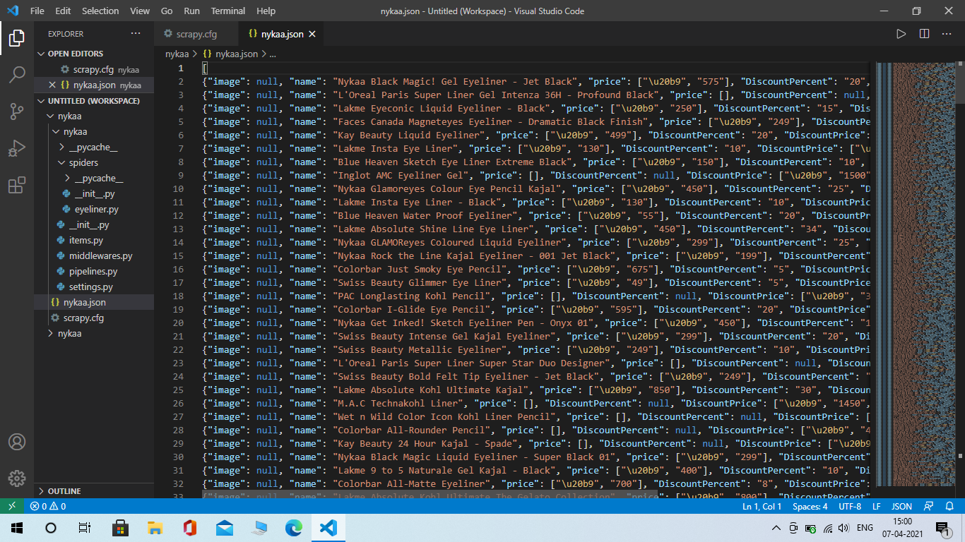

DATA ANALYSIS USING JSON FILE:

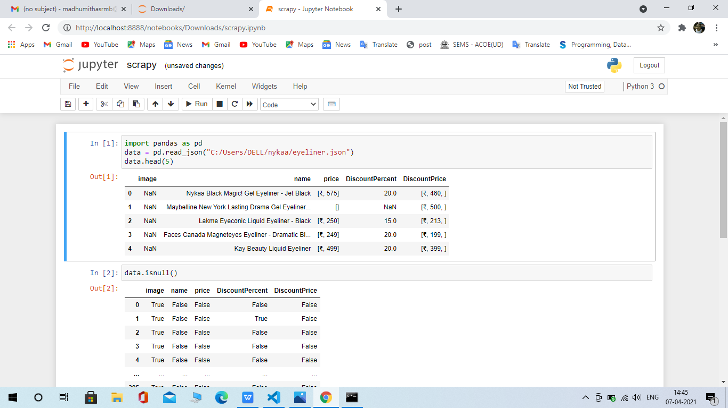

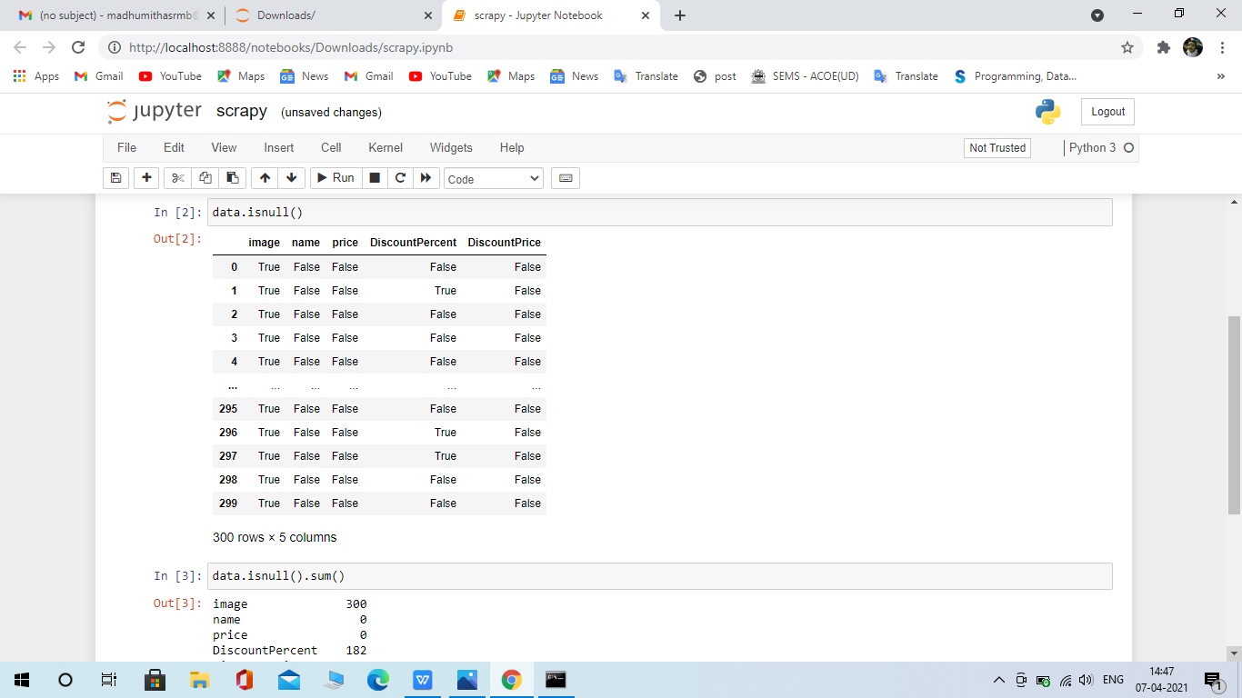

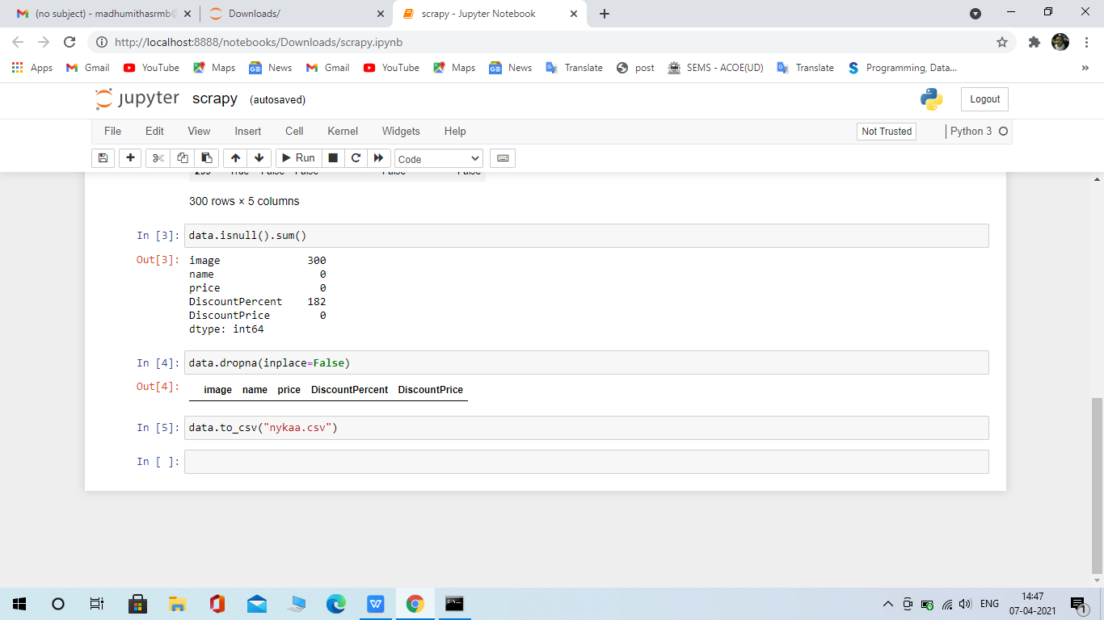



CONVERTED JSON TO CSV FILE :

